Traffic diversion in TMC simulator

1. Understanding diversion

I’ll use the example of Paul in this message.

The following information abstracted from Paul’s message will be the inputs to Paramics simulation. In addition to the three diverted traffic streams, some vehicles on south I-5 may also divert to some other freeways (or alternative routes) and then travel back to southbound I-5 later. I assumed percentage information to each diverted traffic stream. Percentage is defined as the percentage of traffic heading for “To” from “From” will reroute. Using the first traffic stream as an example, its percentage means the percentage of traffic volume heading for S-5 from E-91 will re-route (go straight on E-91).

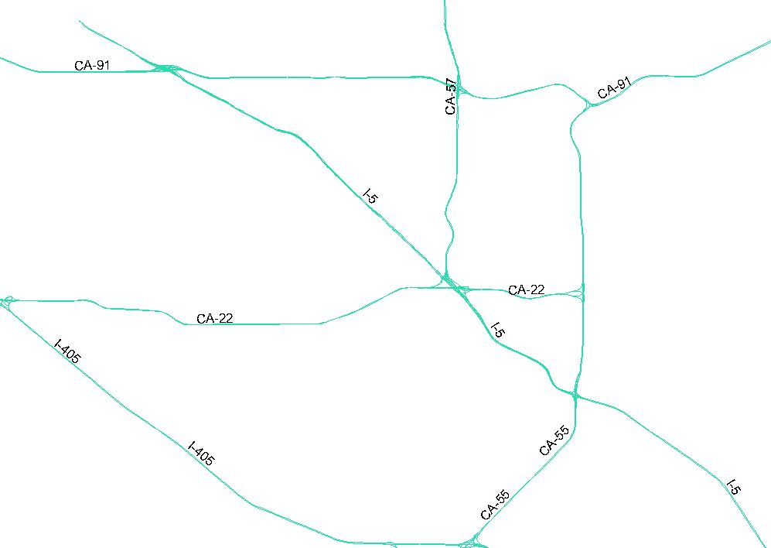

FROM | TO | Percentage | Diversion path | Action at the diversion point
E-91 | S-5 | 50 | E-91,S55,S5 | Go straight (no turn at connector to I-5)
S-57 | S-5 | 25 | S-57,E-22, S55,S5 | Exit to E-22
E-22 | S-5 | 50 | E-22,S55,S5 | Go straight (no turn at connector to I-5)
S-5 | S-5 | 10 | S-5,E-91,S55,S5 | Exit to E-91
S-5 | S-5 | 10 | S-5,E-22,S55,S5 | Exit to E-22

Example: Assuming the traffic volume on E-91 (before the junction with I-5) is 4000. Among them, 1000 is planning to travel to I-5 using the connector to I-5 (based on its route choice). As a result, 50% diversion will cause 500 vehicles to drive to I-5 and another 500 vehicles will continue straight.

2. Implementation:

2.1 Diversion data from CAD:

CAD needs to send the following data to Paramics:
(1) “From” (FROM route)
(2) “To” (Planned route where there is incident);
(3) Diversion path (Alternative routes);
(4) Percentage.

There will be a Management section in the XML file used for communication.
<Management>
<Diversion>
<From>E91</From>
<To>S5</To>
<Diversion_path>
<Route>E91</Route>
<Route>S55</Route>
<Route>S5</Route>
</Diversion_path>
<Percentage>50</Percentage>
</Diversion>
</Management>

2.2 Data processing after Paramics receives data from CAD:

Any a network needs a lookup table, used to process the data from CAD and then provide the following data for Paramcis to use for the diversion purpose.
(1) Diversion point (and the decision point of diversion, two links before the diversion point, required by Paramics));
(2) Diversion path in Paramics, composed of a series of Paramics nodes.
(3) Percentage.

The lookup table needs to prepare in advance. Caltrans needs to provide all possible diversion routes for each simulation network.

2.3 Logic in Paramics plugin:

Y
Observe vehicles at the decision point of a diversion point (on FROM route)
Diversion is enabled
Find diversion point, diversion path from lookup table
Receive diversion data from CAD
Heading for “TO” ?
Choose a diverted vehicle based on the diversion percentage
The picked vehicle follows the given diversion path afterwards (override Paramics path)

